六 年 級 英 語 科 Class: Number: Name：
新 竹 縣 照 門 國 民 小 學 一 百一 學 年 度 第一學 期 第 三 次 學 習 效 果 評 量
A. Listen and check(15%)圈選出聽到的母音
1. a_e a | 2. ai a | 3. ay a | 4. ee e | 5. ea e
6. i_e i | 7. ie i | 8. y i | 9. o_e o | 10. oa o
11. ow o | 12. ue u | 13. ue u | 14. oo o | 15.oo o

B. Listen and circle (20%)圈選出聽到的單字
(1) 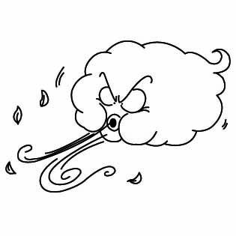 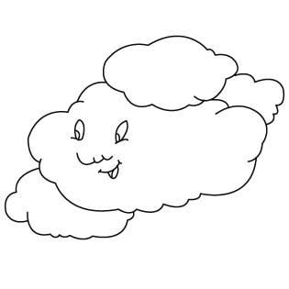 (2) 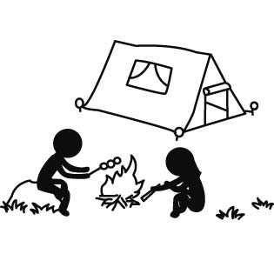 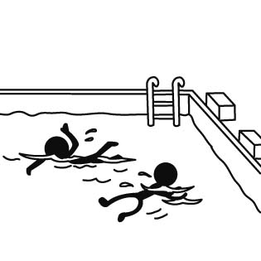 (3) 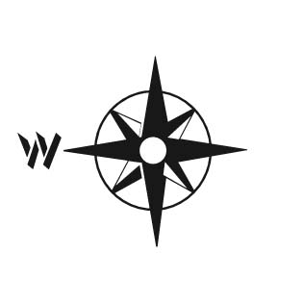 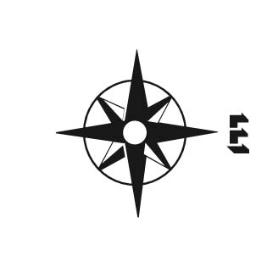
(4)  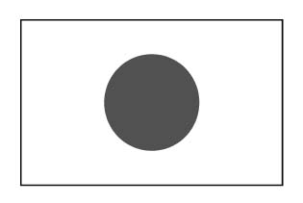 (5) 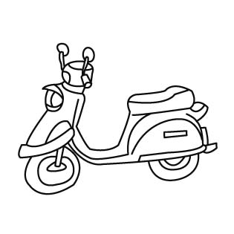 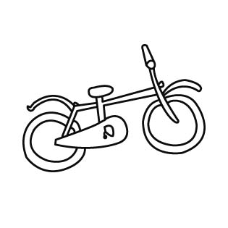 (6) 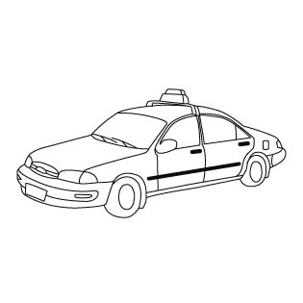 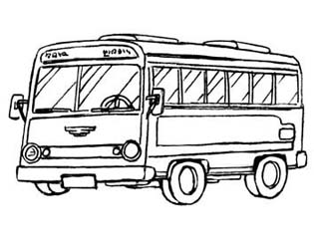
(7) 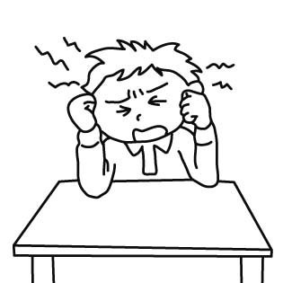 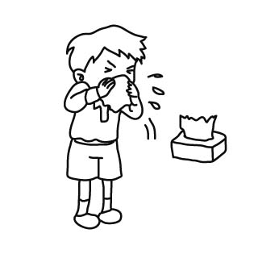 (8) 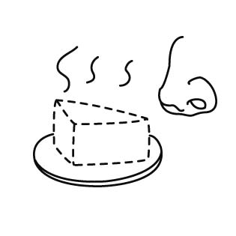 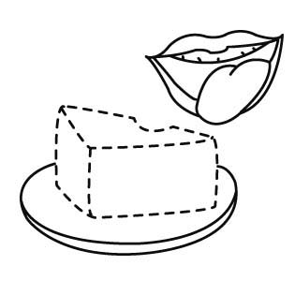 (9) 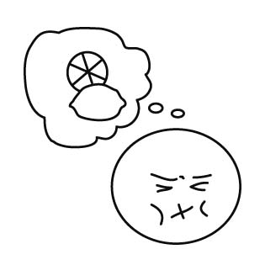 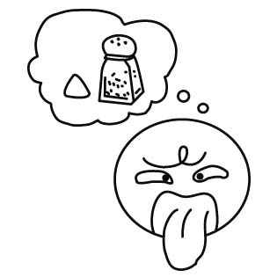
(10) 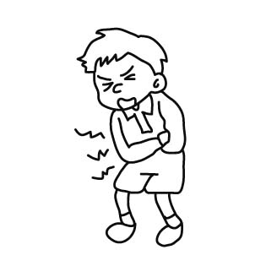 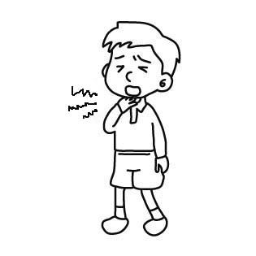
C.fill in the blank(20%)填寫單字,注意文法是否需要加s
stomachache America fever bitter north
taste(s) go(es) camping rainy plane scooter
1. The cake good.
2.Taipei (台北) is in the of Taiwan.
3. I want to in the summer vacation(暑假).
4. It is , I can't go hiking.
5. Let's go to the Japan. We can get there by .
6. We eat too much, and we all have a .
7.The coffee is too to drink.
8. Jeremy Shu-How Lin (林書豪) is from .
9. My mother goes to work by .
10. I have a ,I can't eat ice cream.
D. Read and choose the best answer(20 %)選出正確的答案
 | 1. What ____________ you want to do on Saturday? (A) are (B) do (C) does |  | 2. The ice cream ____________________ good.  (A) looks (B) smell (C) taste
 | 3. What _______ Tony want to do?  (A) do (B) does (C) is |  | 4. Monkey King ____ to go camping.  (A) like (B) likes (C) want
 | - 5. your mother have a fever? (A) Do (B) Is (C) Does |  | 6. The princess ______ a magic fan.  (A) is (B) does (C) has
 | 7. The soup is too salty to eat.  (A) The soup is hot. .  (B) The soup is not salty.  (C) The soup is salty. |  | 8. The ice cream is too cold to eat.  (A) The ice cream is not cold.  (B) I want to eat the ice cream.  (C) The ice cream is too cold. I don’t want to eat it.
 | 9. Ola and Kasia ___________ from Poland.  (A) are (B) is (C) am |  | 10. I want to go to the post office. How ________ I get there? (A) am (B) can (C) is
 | 11. What is wrong with ______ ?  (A) him (B) she (C) he |  | 12. You’re _ ____ the Teeny-Tiny World.  (A) on (B) of (C) in
 | 13. ____ Monster Bull and the princess have a cold? (A)Are (B)Do (C) Does |  | 14. The tangerines __ sour.  (A) taste (B) tastes (C) smells
 | 15. The park is ____________ the east of the school. (A) in (B) at (C) on |  | 16. I am ____________ home.  (A) go (B) goes (C) going
 | 17. Everyone ____ a runny nose.  (A) is (B) have (C) has |  | 18. Monkey King __ __ Monster Bull away. (A) kicks (B) kicking (C) kick
 | - ____ is the weather in Japan?  (A) What (B) How (C) Where |  | 20. What do you eat __ the Chinese New Year? (A) at (B) on (C) during
E. Unscramble the sentences（25%）句子重組:
1. today ∕ How's ∕ weather ∕ the ∕ ? ∕
2. Taiwan ∕ country ∕ a ∕ is ∕ wonderful ∕ . ∕
3. we ∕ by ∕ get ∕ Can ∕ there ∕ ? ∕ bike ∕
4. fan ∕ I ∕ your ∕ . ∕ need ∕ magic ∕
5. go ∕ don't ∕ . ∕ to ∕ want ∕ out ∕ I ∕

